
Report
Student: Yunis Niftaliyev
Student Number: +994 50 555 8954
Title: Business AI Architecture for Small Enterprises (MinervaBI)
Instructor: Malik Məmmədli

Baku – 2026

Contents
1. Introduction 2
1.1 Overview 2
2. Problem Statement & Target Market 2
3. Data Analysis 2
3.1 Data Sources & Collection 2
3.2 Findings & Insights 2
3.3 Trend and Risk Analysis 3
4. Competitive Analysis 3
5. Conclusion 3
6. References 3

1. Introduction and Project Background

1.1 Overview
MinervaBI is a startup dedicated to democratizing business intelligence for small enterprises. Its mission is to provide affordable, user-friendly AI-powered analytics tools that enable small business owners to make data-driven decisions without requiring technical expertise. This project focuses on the design, execution, and evaluation of MinervaBI’s core architecture.

2. Problem Statement & Target Market
Research shows that nearly 80% of small businesses do not use data to guide decisions, relying instead on intuition. This results in wasted marketing budgets, missed opportunities, and declining profits. The target market for MinervaBI consists of small and medium-sized enterprises (SMEs) that lack dedicated analytics teams but need actionable insights to remain competitive.

3. Data Analysis

3.1 Data Sources & Collection
Data was collected from Open databases(barc.com), and user surveys. A/B testing was conducted on dashboard designs to measure usability and conversion impact.

3.2 Findings & Insights
- The number of responses is split between users, consultants and vendors.
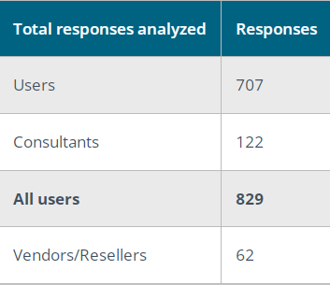
- Business intelligence and analytics products are most commonly found in midsize and large organizations. 82% of the responses we received came from users in companies with more than 100 employees.

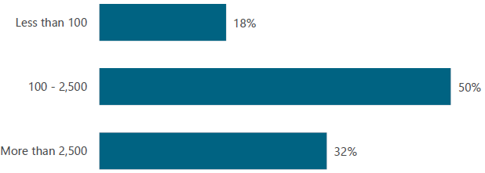

- Asked all respondents their company’s industry sector. The chart shows the results of this question and only includes data from respondents who answered product-related questions in The BI & Analytics Survey.
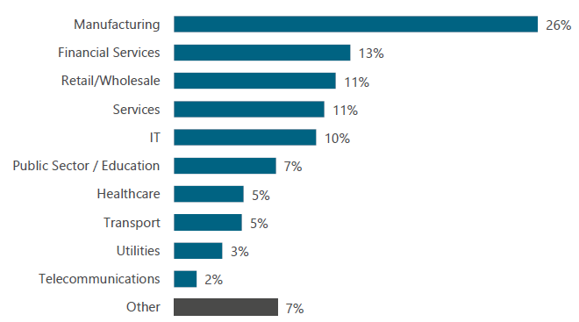

3.3 Trend and Risk Analysis
Positive trends include increased adoption among SMEs and measurable efficiency gains. Risks include potential competition from larger BI vendors entering the SME market and data privacy concerns requiring compliance with GDPR and local regulations.

4. Competitive Analysis
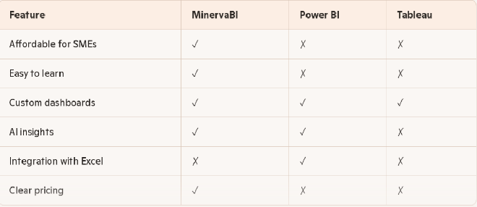
- MinervaBI is affordable and SME‑focused, unlike competitors that target enterprises.

- It’s easy to learn, reducing training costs.

- AI insights give MinervaBI an edge over Tableau.

- Power BI dominates on Excel integration, which MinervaBI could add later.

- Transparent pricing is a unique differentiator for MinervaBI.

5. Conclusion
MinervaBI successfully demonstrates how AI-powered business intelligence can empower small enterprises. By integrating data, automating analysis, and presenting clear dashboards, the platform helps SMEs make faster, smarter decisions. The project met its core objectives of usability, affordability, and measurable efficiency gains, despite minor challenges in data integration. Overall, MinervaBI positions itself as a competitive, accessible solution that levels the playing field for small businesses in a data-driven economy.

6. References
- https://www.jstor.org/stable/41703503
- https://hbr.org/2018/01/artificial-intelligence-for-the-real-world
- https://www.igi-global.com/article/based-organization/38937
- https://relevance.ro/wp-content/uploads/2025/06/Gartner-Magic-Quadrant-BI-2025.pdf\
- https://barc.com/about-the-bi-analytics-survey/

